Terry E. Ayyad  Construction, infrastructure & development  San Francisco, California · (415) 815-7992 · Tariq3699@gmail.com | 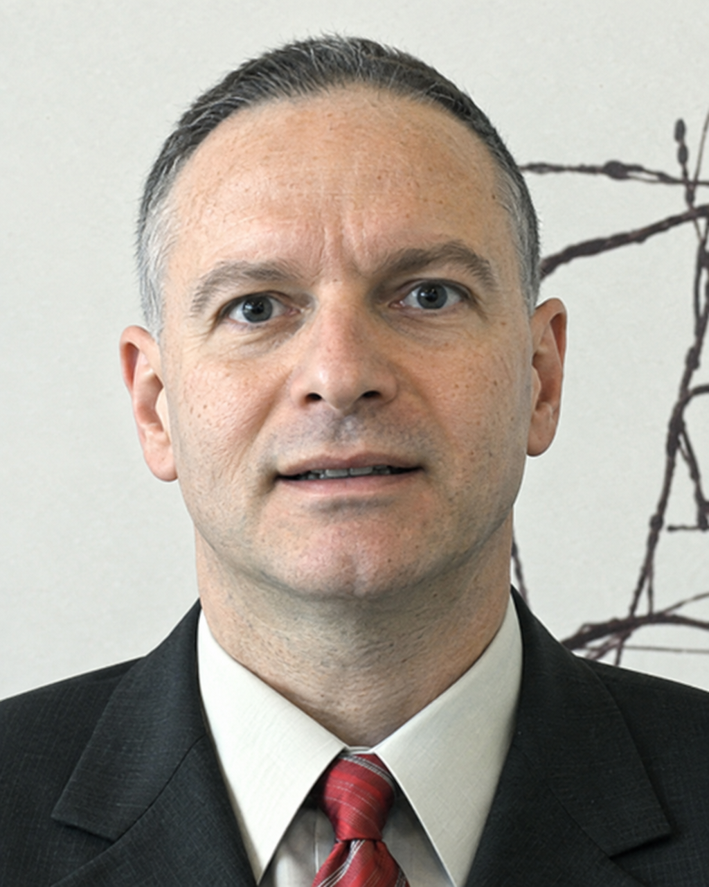
  - Construction and infrastructure executive with more than three decades across aviation, highways, bridges, transit, utilities, water, data centers and commercial buildings. Progressed through field inspection, project engineering, estimating, scheduling and superintendent roles to project direction and company ownership. Expertise in California public-works delivery, international development, claims and change management, and construction technology. ENR Newsmaker honoree and U.S. patent inventor.

Education  PhD · Mathematics  San Luis Obispo, California  1997–1998  M.S. · City & Regional / Urban Planning  California Polytechnic State University, San Luis Obispo  1995–1996  B.S. · Construction Management  California State University, Fresno  1991–1992  Civil / Structural Engineering  California State University, Fresno  1992–1995  Additional undergraduate study / double-major focus.  Awards & recognition  ENR · Top 25 Newsmakers  2003 achievements  Published 12 January 2004  ShareChive construction-information technology.  Read the ENR recognition    Mayoral commendation  Mayor of San Francisco  Telegraph Hill slope-stabilization work  Business & engineering honors  Small Business of the Year  2006  Best Company of the Year  ShareChive · 2005  Engineer of the Year  2005  Best Technology for Construction  ShareChive · 2006 |  | Executive leadership  President & Founder · Global Transit Alliance Corp.  GTAC | Infrastructure development  Lead multidisciplinary planning for the South Suburban Airport development opportunity. Coordinate aviation, architecture, engineering, construction, technology, finance and operations specialists; define responsibilities, interfaces and delivery strategy.  President / Owner · 2040 businesses  San Francisco | Development & Trading: from 2016 · Builders: from 2018  Direct design, development, engineering and construction across Bay Area building and civil projects. Directed 175+ projects, with 180 company projects completed by February 2025. Lead estimating, procurement, field operations, subcontractor coordination and owner relationships.  Aviation & federal facilities  Project management on Plot 2 / Parking Lot C, a Synergy design-build assignment with a $2.37 million original contract award. Expanded airport assignments follow on page 2.
  Delivered airport civil and building assignments spanning Terminal 3 East, Plot 2 / Parking Lot C, West Field Cargo, apron reconstruction, precast-wall work and Garage Levels 4 and 5. Scope includes utility relocation, drainage, water and sewer systems, pump stations, concrete, paving and lighting coordination. |  | 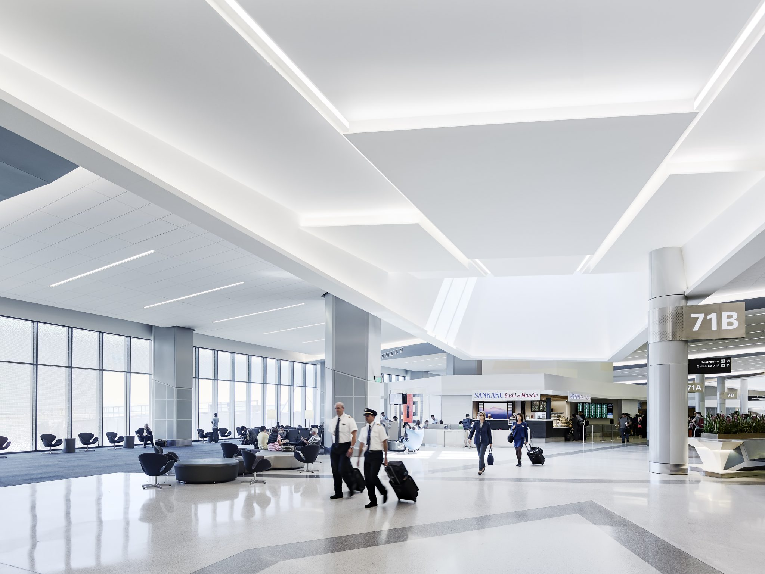  Terminal 3 East · Hensel Phelps
    San Francisco International Airport | 
  Project Director · NASA Ames assignments  Cyber Construction Management | April 2018–July 2020 | 
  Directed design and construction for Building N220 and renovation of Building N202, coordinating the design and construction teams.  Project Manager / Estimator · NASA Ames assignments  K&B for Cyber | December 2015–2018  N240: managed critical-facility renovation and retrofit, with approximately 85,000 sq ft of work scope within a $4 million project. N239: managed roof renovation and design/build greenhouse work on a $1.75 million project. |  | 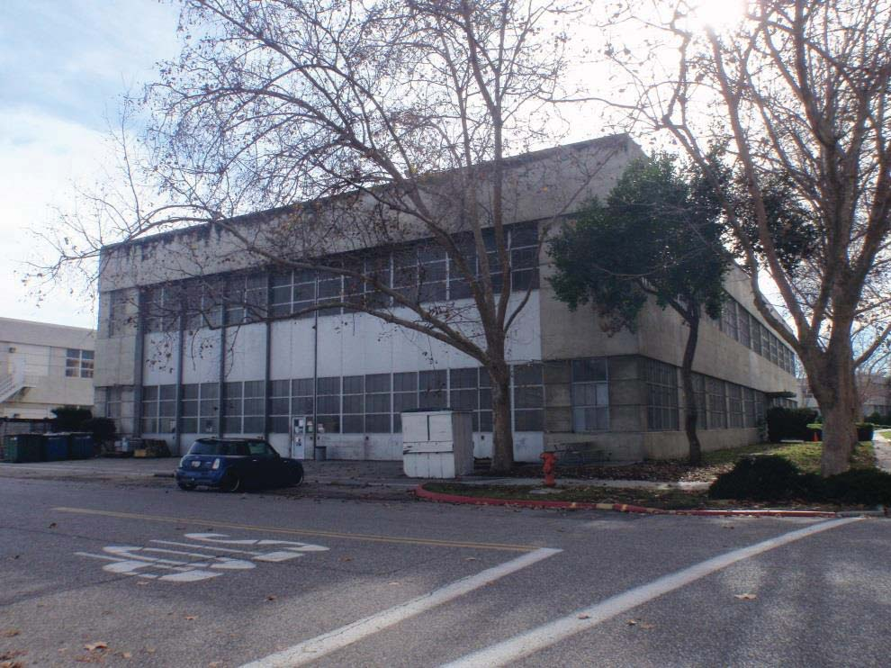  N220 · NASA archive, 2015

Terry E. Ayyad | Airport construction & rehabilitation

Selected airport assignments
San Francisco International Airport · civil infrastructure, terminal works and building rehabilitation
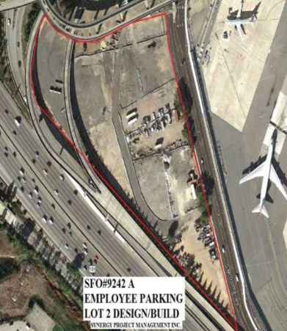  Plot 2 · supplied site plan |  | Project Manager · Synergy Project Management · Contract 9242A · awarded October 2012  Managed parking-lot construction, utilities, site electrical work, concrete and paving. The $2.37 million original design-build contract converted the former Hilton staging site into employee parking, freeing Lot D for revenue parking. SFO planned approximately 800 spaces with a 45-day substantial-completion requirement; parking controls had a separate 120-day milestone.
  Plot 2 / Parking Lot C · design-build | 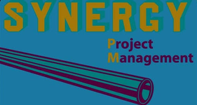

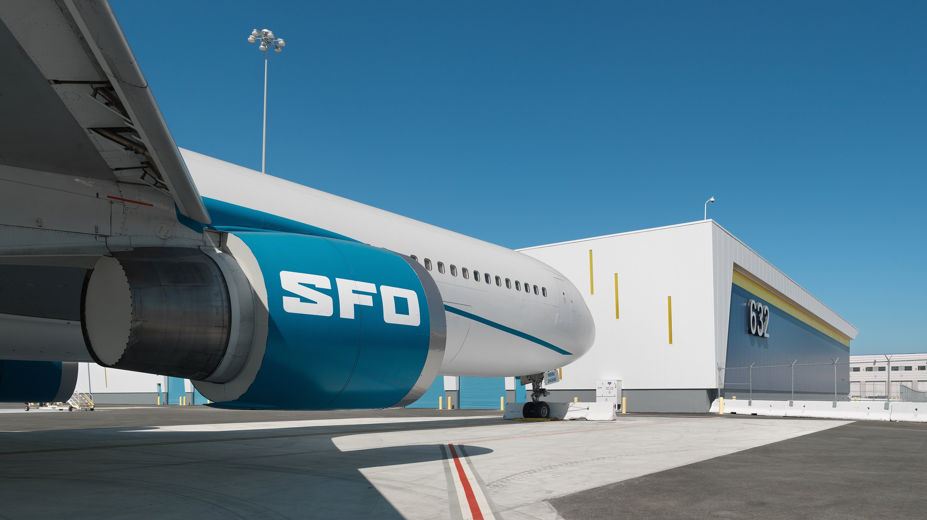  West Field Cargo · McCarthy |  | Airport civil assignments · McCarthy project team  Apron demolition and reconstruction for larger aircraft, water and sewer reconstruction, pump-station work and concrete improvements. The wider 90,000-square-foot cargo facility was delivered through design-build while airport operations continued; airfield access, utilities and construction interfaces required close coordination.
  West Field Cargo · apron & utilities | 

Terminal 3 East · Hensel Phelps |  | Airport construction assignments · Hensel Phelps project team  Underground utility realignment and apron demolition / replacement, including approximately 1,200 cubic yards of concrete. The wider terminal program renovated the concourse and checkpoints and added three gates and a 60,000-square-foot addition, with the airport operating around the clock. Terminal-program completion: November 2015.
  Terminal 3 East · civil & apron work | 

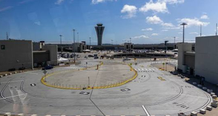  Central Garage |  | Parking-structure rehabilitation · Pullman collaboration  Improvement, repair and structural rehabilitation of the airport parking structure across Levels 4 and 5, including restoration of parking surfaces. Airport-building rehabilitation complements the terminal, apron, utility and parking-lot assignments.
  Central Garage · Levels 4 & 5 | 

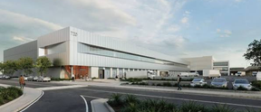  Supplied building illustration |  | Building construction and envelope assignments  Construction of precast walls across three airport buildings, extending the airport experience beyond paving and underground utilities into building-envelope work. Additional cargo-building assignments include construction and renovation in coordination with Skanska and Kiewit.
  Precast walls & airport buildings | 

Terry E. Ayyad | Infrastructure delivery & project controls

Core expertise  Construction leadership  Delivery; field supervision; crews, equipment and subcontractors.  Preconstruction  Estimates; takeoffs; constructability; value engineering; procurement.  Project controls  CPM schedules; progress, cost and schedule-impact analysis.  Contracts & claims  Change orders; claims analysis; negotiation; supporting records.  Civil infrastructure  Bridge retrofit / widening; retaining walls; grading; paving; structural concrete.  Underground systems  Water, sewer, storm drainage; utility relocation; recycled water.  Delivery coordination  Design/build; QA/QC; safety; agency and owner interfaces.  Professional training  • OSHA 30-Hour Construction Safety · AdvanceOnline Solutions. Fall protection, excavation, scaffolds, electrical safety and hazard communication.  • HAZWOPER · 40 hours · Synergy Project Management. Completed 28 January 2016.  • Confined Space · Synergy Project Management.  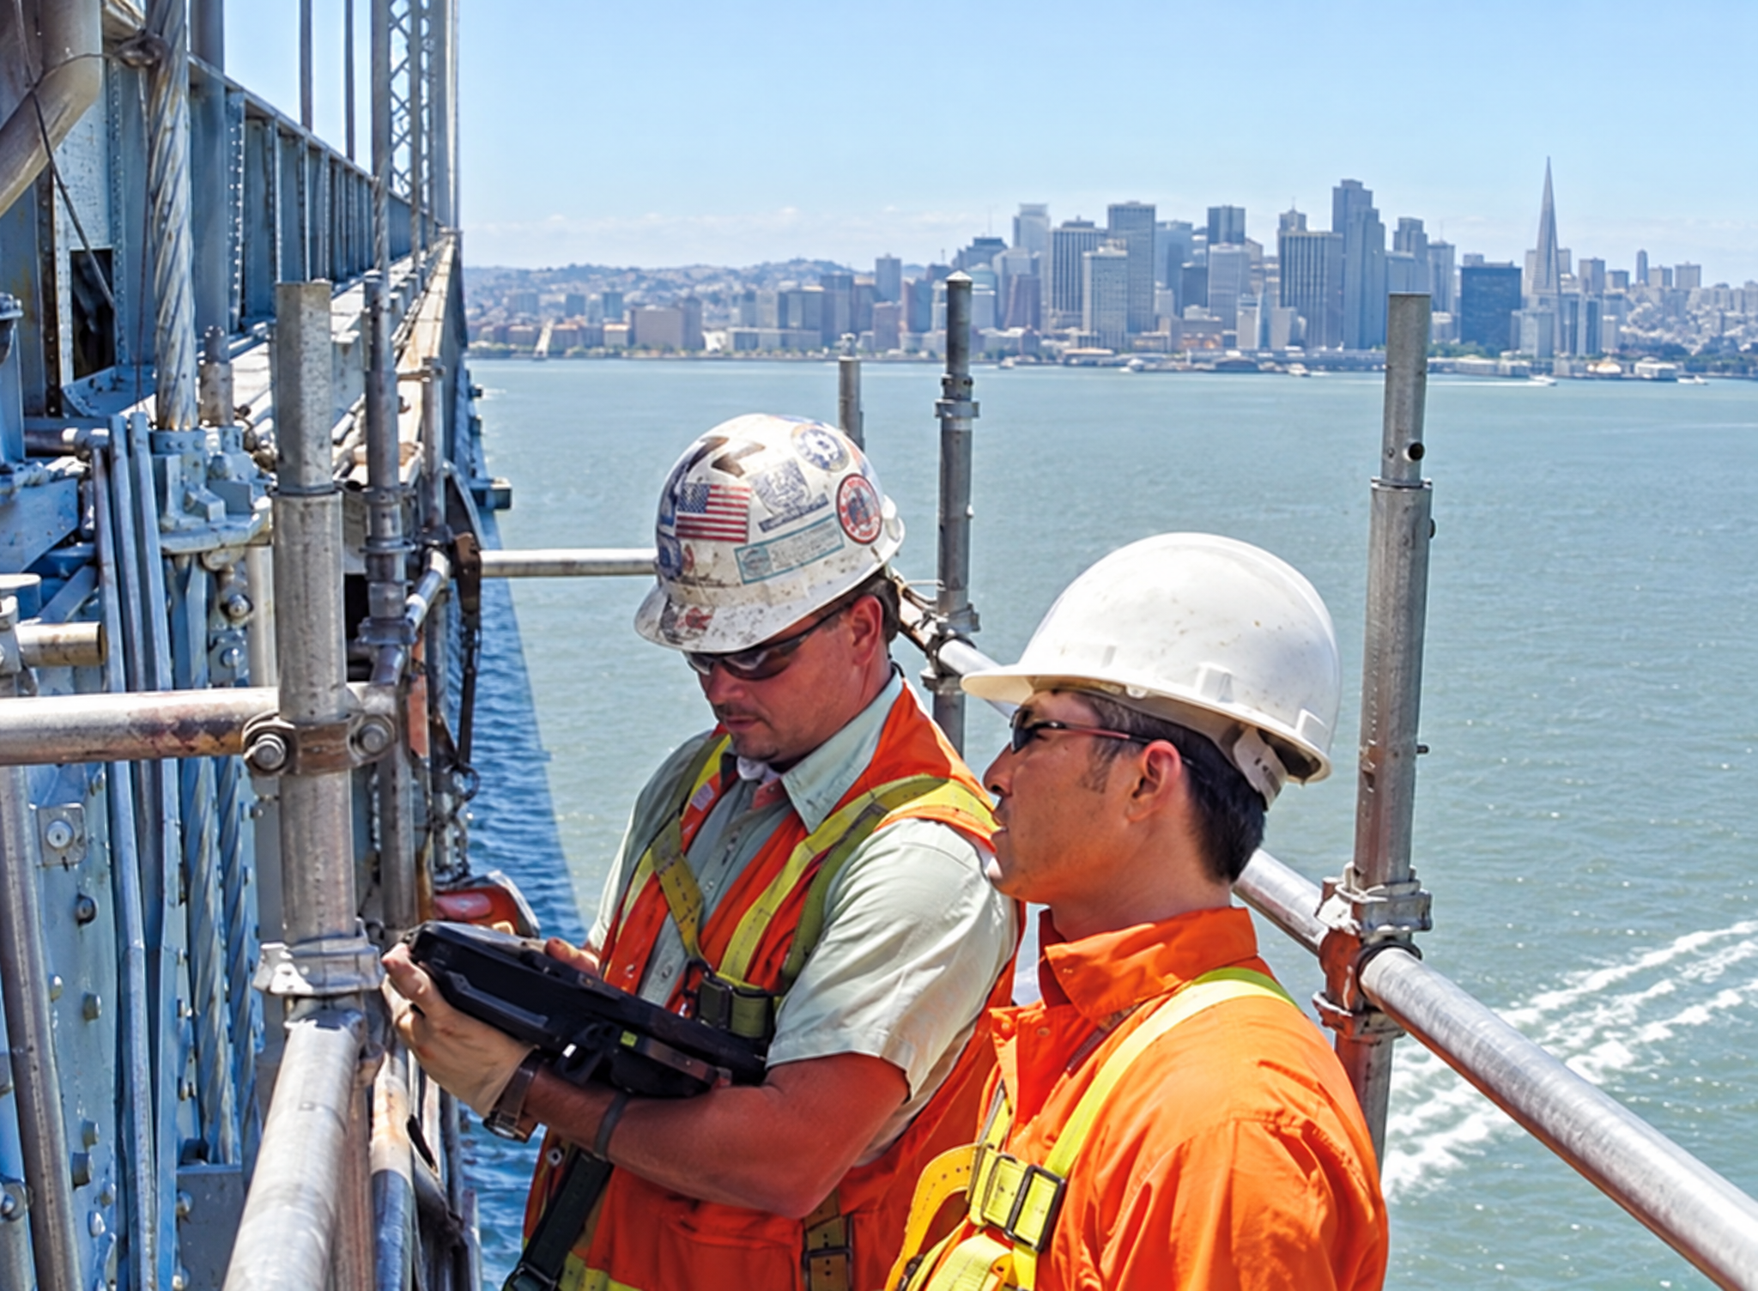  Bay Bridge · field technology  ShareChive / ENR · 2003 · restored  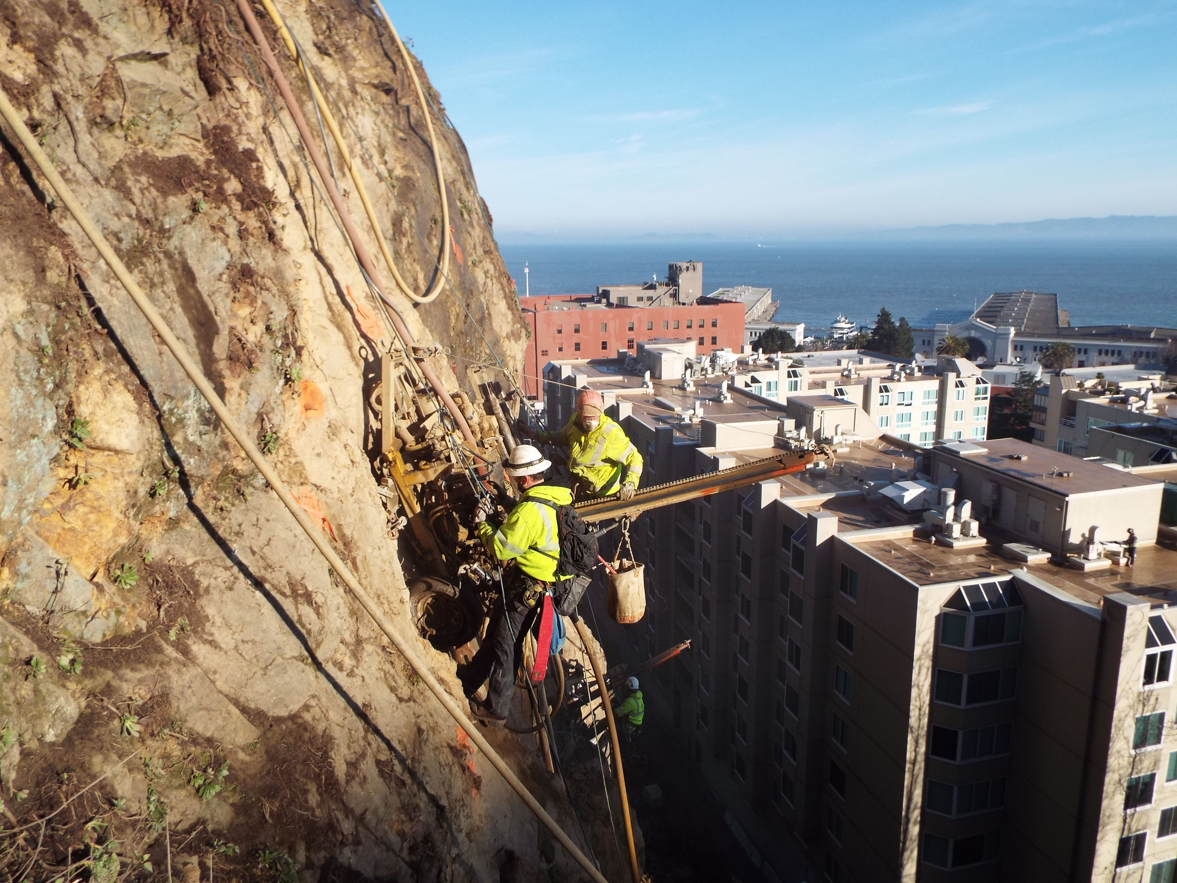  Telegraph Hill · SF Public Works |  | Transit & civil infrastructure  Managed project teams from estimating through construction: schedules, costs, subcontractors, field operations, project administration and accounting. Coordinated RFIs, materials, crews, traffic control, safety and quality.  • Central Subway — 1250, Moscone / portal utilities: water, sewer and utility relocation ahead of subway construction. Synergy’s completed contract reached $11.97 million final value.  • Central Subway — 1251, Union Square / Market Street: relocated water, power, gas, communications, street lighting and signals, with temporary trolley-coach rerouting. Synergy’s completed contract reached $20.70 million final value.  • Central Subway — 1252: utility reconstruction and excavation within the tunnel subcontract scope. Union Square: granite repair and replacement associated with subway construction.  • Point Lobos / Great Highway — SFDPW 1936J: water-main, sewer and storm-system replacement, pavement, curb, gutter, sidewalk, median and landscape works.  • Hunters Point Phase II — Cahill / Nibbi: on-site and off-site sewer, drainage, low-pressure water, recycled-water and concrete works; $3 million scope.  • Road rehabilitation: Caltrans Highways 35, 24, 84, 29, 12, 101 and 58, plus San Mateo County street works; individual projects valued from $0.5 million to $3 million.  • SFDPW 2159J: underground infrastructure, flatwork and street resurfacing; $5 million scope.  Bridge delivery & controls  Bay Bridge West Span retrofit: managed an assigned span as area superintendent; planning, materials, field verification, changes and crew oversight. The wider CEC / Modern Continental project strengthened trusses and towers, added lateral bracing and hydraulic dampers, and maintained traffic through staged work. Rio Vista Lift Bridge: area superintendent on the $4 million retrofit.  Additional Bay Bridge assignments: construction of two ramp landings, removal of existing ramps, and island-to-bridge approach work.  Flyover construction: bridge construction with Myers and Ghilotti, including steel-beam installation. Golden Gate Bridge: movable median-barrier installation; the wider safety project was installed in January 2015, separating opposing traffic while allowing lane configurations to change.  Scheduler · MCM Construction  Sacramento, California | February 2003–April 2004  Scheduled California bridge projects from award to completion; maintained progress and cost information, assessed claims and change orders, and coordinated with project owners.  Emergency slope stabilization  Project coordination on the SF Public Works / GeoStabilization International Phase 1 works, November 2014–June 2015, below Coit Tower along Lombard Street. Stabilized a hillside with recurring rockslides through loose-rock removal, anchored steel, wire mesh and shotcrete. The wider project installed more than 400 rock anchors, with drill holes up to 30 feet deep, protecting nearby buildings, streets and public access around the historic landmark. Received a commendation from the Mayor of San Francisco for this work.
  Project Director · Synergy Project Management  San Francisco, California | January 2010–May 2017 | 
  Project / Area Superintendent · California Engineering / CEC  Pleasanton, California | April 2004–February 2005 | 
  Telegraph Hill · below Coit Tower | 

Terry E. Ayyad | Technology & international development

Patent  U.S. 7,860,827 B1  Inventor: Tariq Ayyad  Filed 23 October 2006  Granted 28 December 2010  Data synchronization method for an application database available on multiple wirelessly connected platforms.  Assignee at grant: Field Automated Communication Systems, LLC.  Read the patent publication  Selected press  ENR covers · restored  2003 recognition published January 2004.  ENR · May 2007  Noor City presidency and development of the proposed Red Sea crossing.  Red Sea crossing coverage  Industry speaking  Keizai Society · 2003  Invited speaker  Wireless IT Application  25 September · Palo Alto  Organizer announcement  Agency implementation  FACS deployments and pilots in California, Maryland, Florida, New York, Illinois and Nevada by 2005; Minnesota rollout planned for 2006.  NYSDOT / AASHTO submission  Software  Primavera P6  AutoCAD · MicroStation  Agtek · Adobe Acrobat |  | Construction technology  Founder / President & CEO · ShareChive LLC  San Francisco | Early 2000s–2007  Led a 42-person organization developing and commercializing construction-information systems. Delivered on-site technology, database management, systems integration, construction consulting and training, drawing on field delivery, scheduling and claims experience.  • FACS platform: rugged tablets, project drawings and specifications, daily reports, quantities, schedules and field / office communications linked to a shared database.  • Synchronization: field access when connectivity was intermittent, with project changes shared between devices and the central database when connections became available.  • Agency workflows: product customization, systems integration and user training; development cooperation with IBM for software and Northrop Grumman for hardware.  • Industry recognition: ENR Top 25 Newsmakers honoree for 2003 achievements in construction-data technology; inventor of the related U.S. synchronization patent granted in 2010.  International development  Business Development Director · Noor City Development Corp.  United Arab Emirates | February 2007–January 2010  Led a 15-person team on bridge, urban-planning, tower, refinery-concept and technology developments across the Middle East and Africa. Coordinated government relationships, specialist teams, budgeting and financing discussions. Served as company president in 2007.  Selected development and project assignments  • Bridge of the Horns — Yemen / Djibouti: proposed 28.5 km crossing; design and development coordination, right-of-way, financing strategy, environmental and government interfaces.  • Noor City, Yemen / Noor Al Sahara, Morocco: city and infrastructure development / master-planning assignments. Bridge of Kings: proposed Morocco–Spain crossing development.  • Shahla Tower, Dubai Marina: contributed to design, development and construction of a 44-floor tower. Trio Towers, Tripoli: design / development proposal for three 80-floor towers.  • Fujairah terminal: design / development of a 1.5 million m³ oil and gas facility. Ras Al Khaimah: 150,000 m³ slop-oil terminal and refinery development planning.  • Azov terminal: contributed to design, development and construction of 1.5 million m³ oil and gas storage. Basra: development of a proposed 175 MW combined-cycle power plant.  • Jeddah Chamber of Commerce: special steel design/build construction; $2.8 million assignment. Emaar / Noor hospital: construction involvement in a four-floor, 220-bed facility.  Director of Operations / Development · Noor Oil / Noor Energy  2008–2010  Directed oil and energy development, specialist coordination and a 12-person team.  Head of Development / Operations · Sjmova  UAE / Iraq | 2009–2010  Directed building, hospital and energy consultancy and a nine-person team.  Program controls & claims  Led seven schedulers managing schedules and claims across 76 Caltrans projects within a $235 million annual program. Reviewed schedules, changes and claims on projects valued from $5 million to $200 million. Reviewed major change orders under District 4 leadership, contributing to state policy guidance.
  June 2003  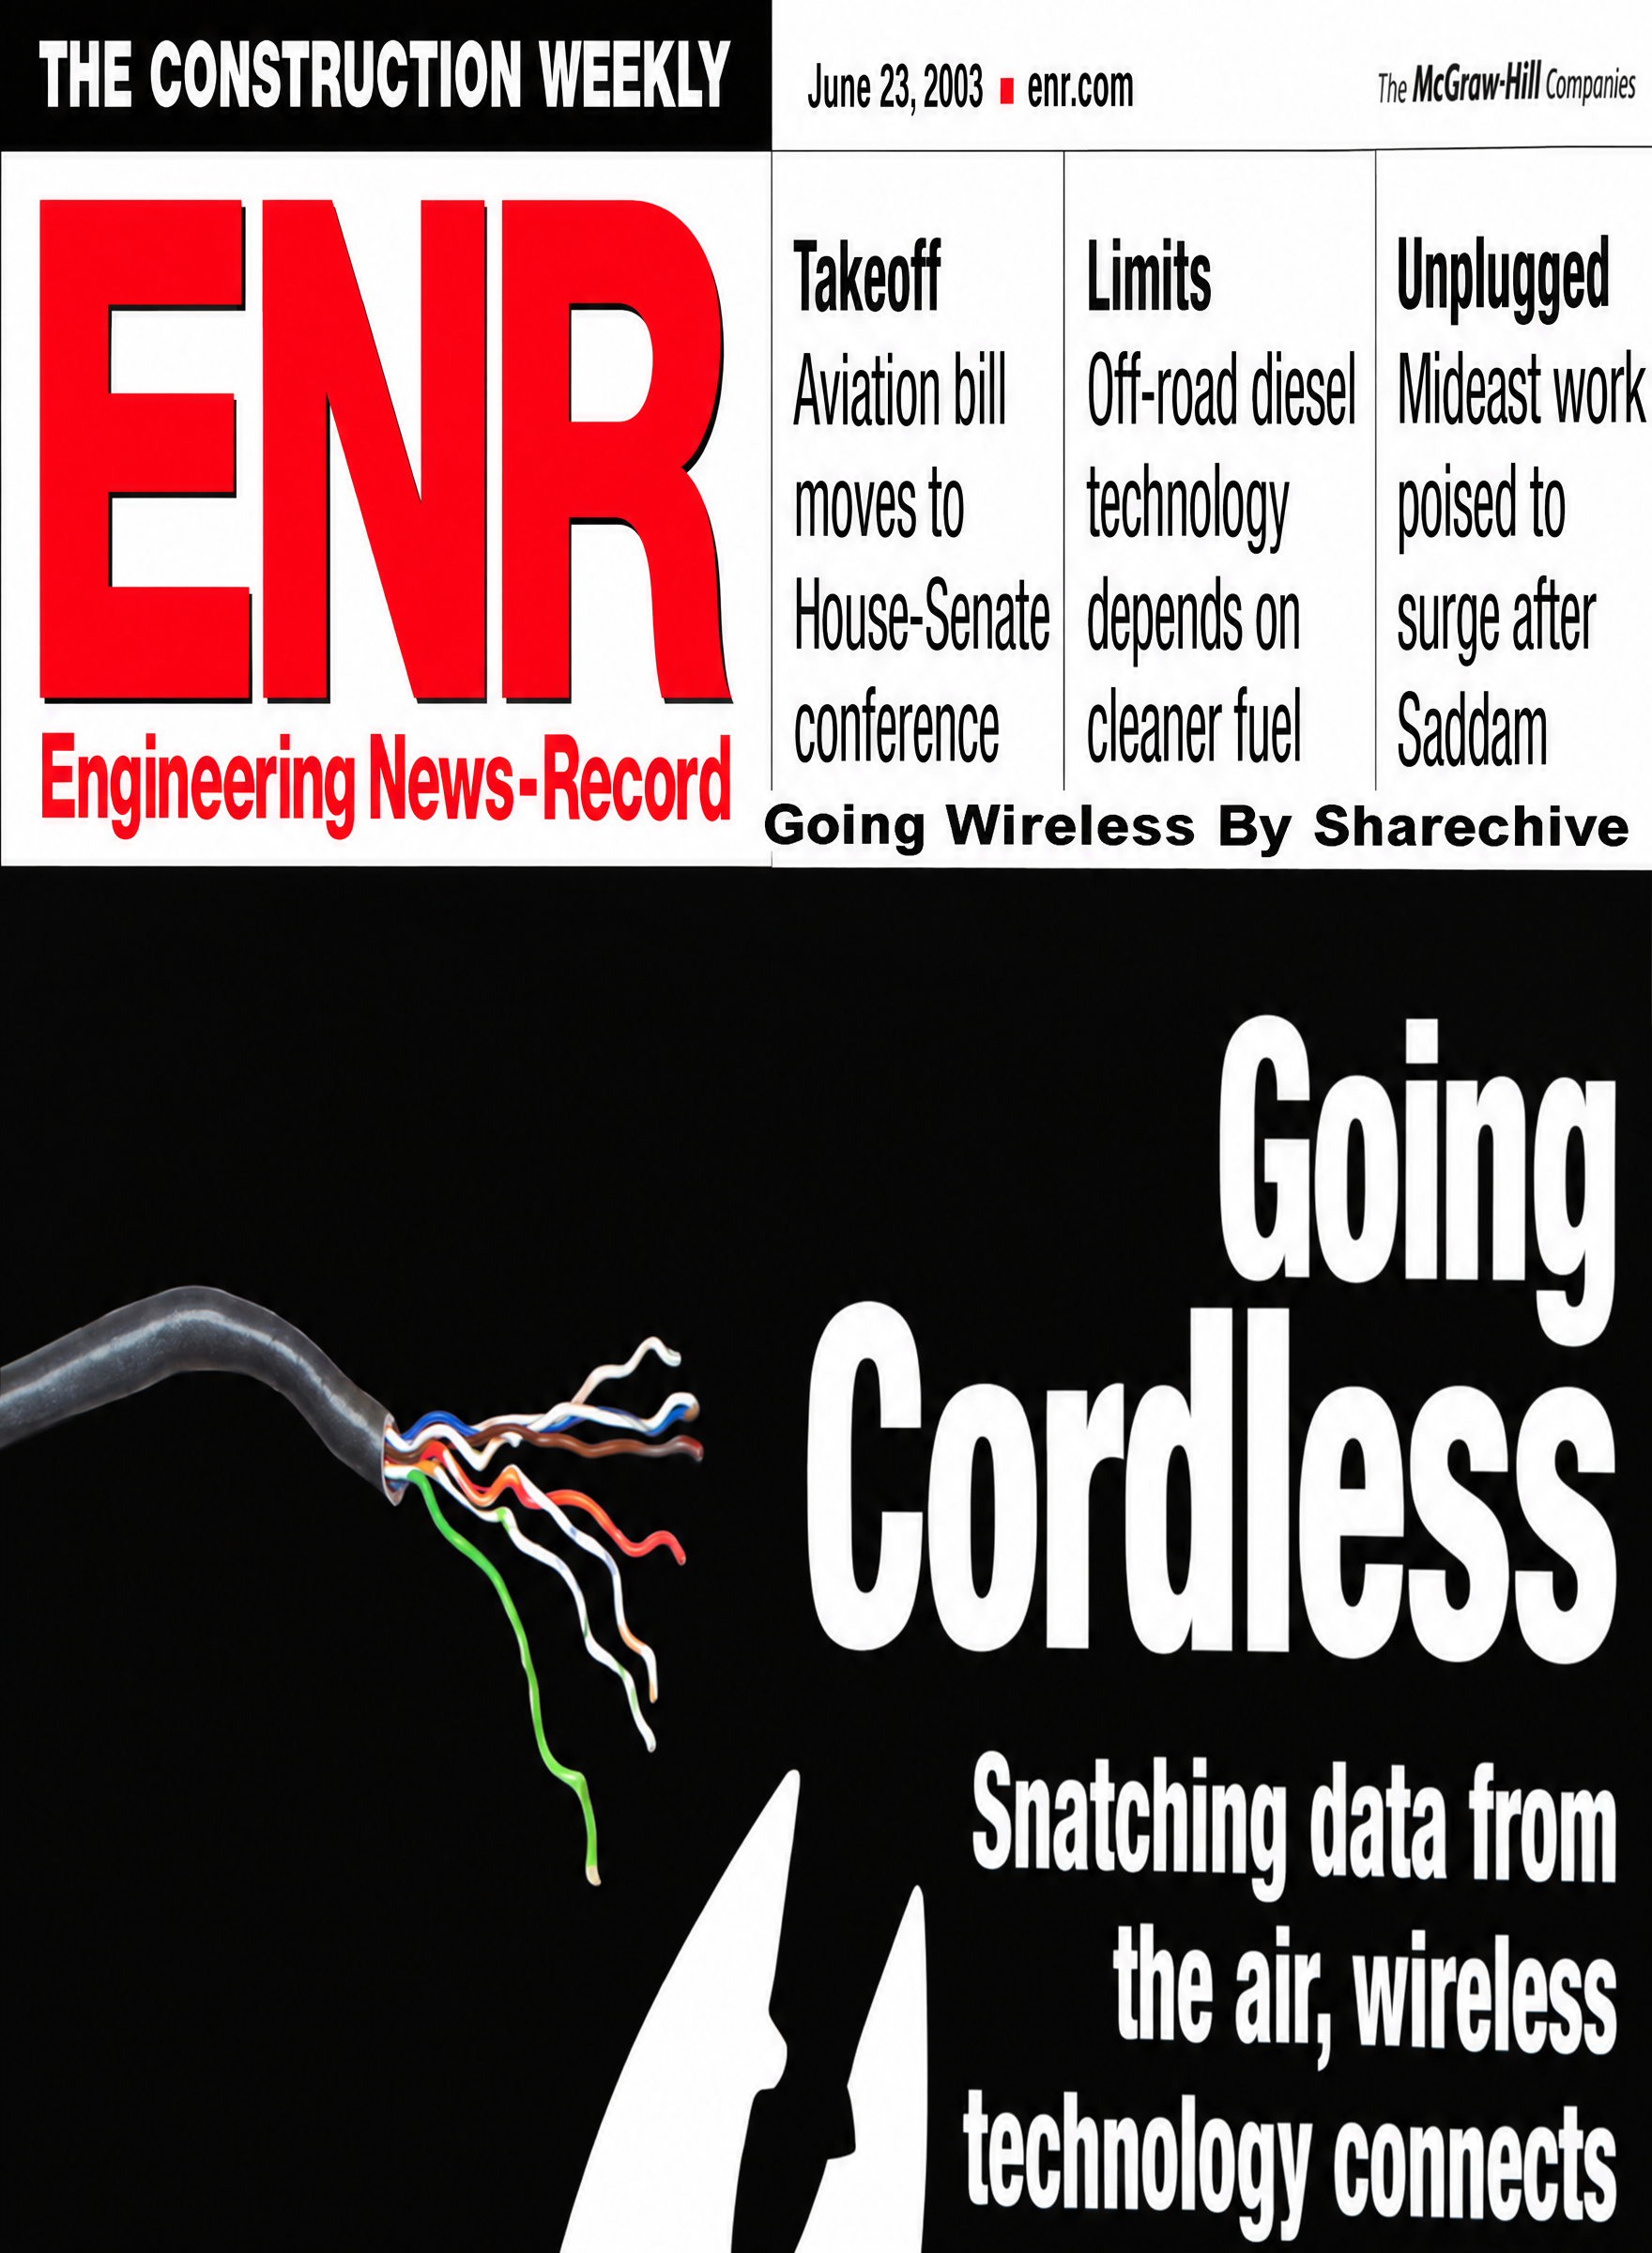  Wireless field systems |  | January 2004  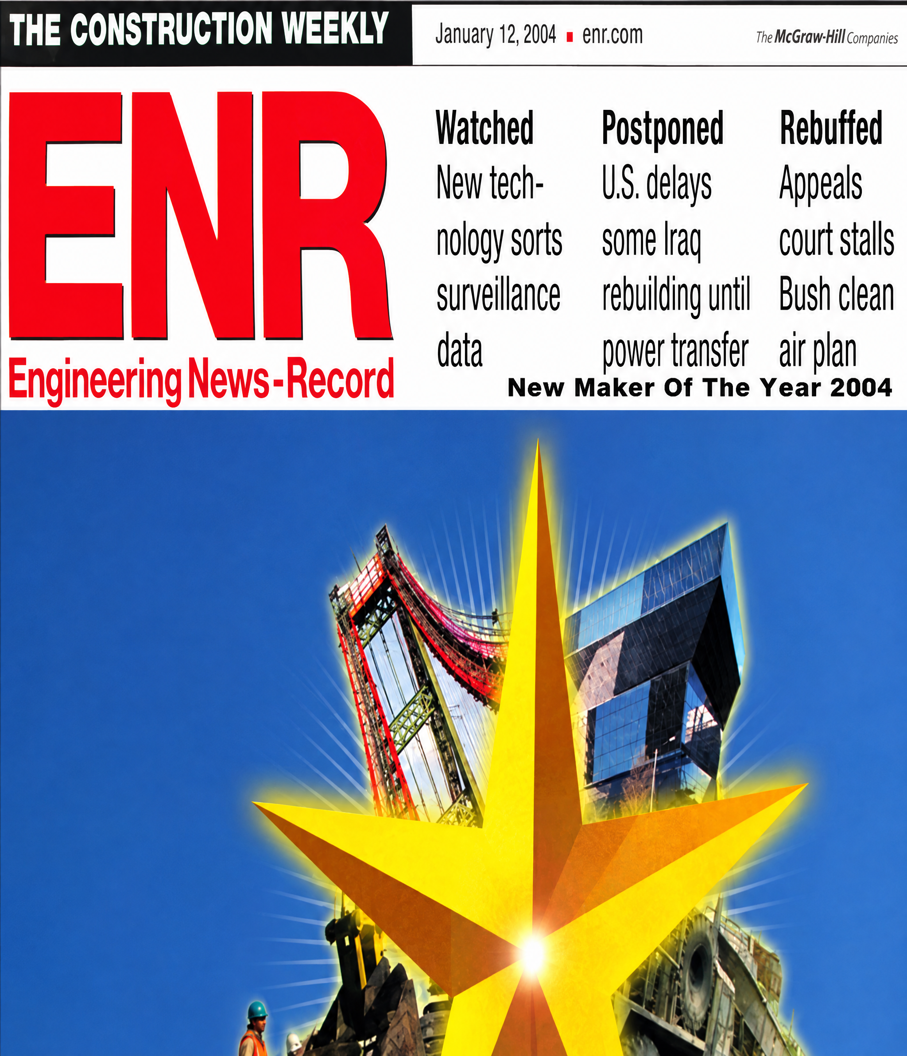  2003 Newsmaker honor
  Head of Scheduling / Claims · TRS Consulting  Caltrans assignments | Sacramento / District 4 | February 2005–February 2007 | 

Terry E. Ayyad | Data centers, rail & commercial construction

Project focus  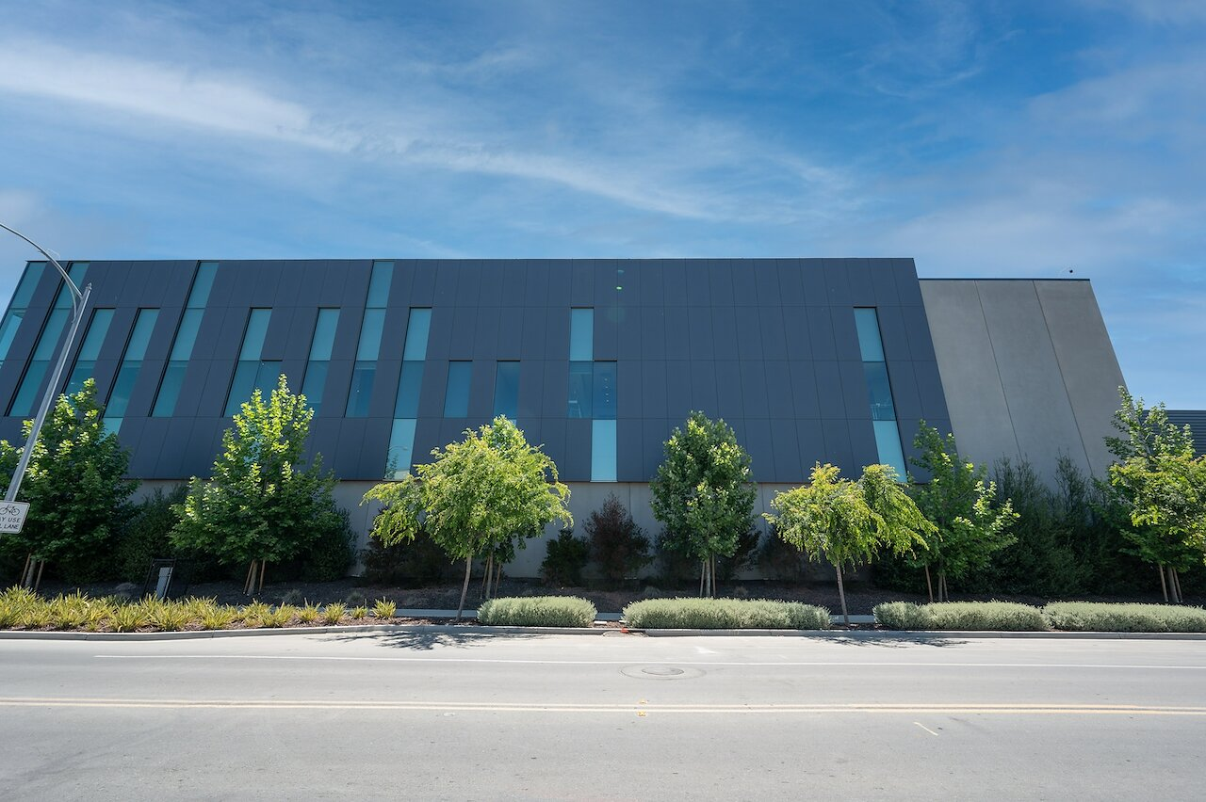  Equinix SV11 · San Jose  Original Equinix project photograph  Mission-critical facilities  Data-center construction; underground power, fiber and utilities; concrete foundations and precast systems.  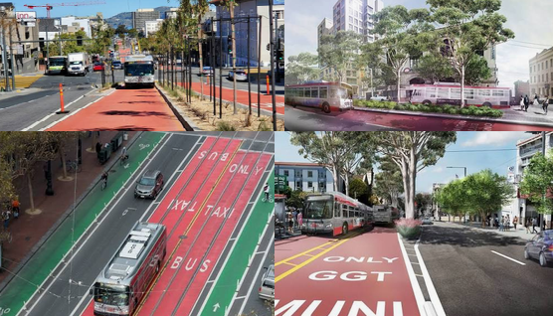  Van Ness · transit improvements  Active rail environments  Platform and deck replacement, sidewalks and ADA improvements around operating rail infrastructure.  800-foot platform  Richmond rail-platform replacement scope.  Five bank locations  North Bay interior, exterior and accessibility improvements.  Additional building work  Target / New Market  Approximately 105,000 sq ft of retail renovation.  SFPUC facilities  Eight clarifier-tank repairs and Bayview operations campus work.  Further assignments include multistory buildings and single- / multifamily housing. |  | Data centers & critical infrastructure  Construction involvement · 2020–2023. Worked on data-center construction at Equinix’s Great Oaks campus. The two-story SV11 facility’s initial phase provided more than 61,000 sq ft of colocation space and capacity for 1,450 cabinets, using modular construction for space, power and cooling.  Construction work encompassing underground utilities, power and fiber, footings and slabs, prestressed precast walls and double-tee roof construction. Oakland assignments also include Logan Pass work of approximately 7,500 sq ft and power / utility coordination.  Rail platforms & transit improvements  2040 Builders. Replacement of approximately 800 feet of platform center deck, with ADA platform improvements in a station environment serving four active main tracks.  Lodi Amtrak · station accessibility  Sidewalk replacement and repair / replacement of the raised platform, including ADA accessibility improvements.  Participated in median and transit reconstruction associated with the Walsh project team. The wider two-mile corridor between Lombard and Mission streets combined center-running bus lanes, boarding platforms, utility replacement, paving and pedestrian improvements.  Commercial facilities & civic improvements  2040 Builders. Site improvements and facility expansion for the South San Francisco warehouse assignment associated with Amazon and Renaissance Companies.  Interior construction and upgrades, exterior civil improvements and ADA compliance across five bank locations, associated with Wells Fargo and Eric F. Anderson.  Golden Gate National Cemetery · San Bruno  Utility and civil improvements, including walls and foundations for signage and building work.
  Equinix SV11 · San Jose | 
  Comcast · Oakland data center | 
  Richmond · ADA platform replacement | 
  Van Ness · bus rapid transit corridor | 
  South San Francisco · warehouse expansion | 
  North Bay · five bank renovations | 

Terry E. Ayyad | Construction foundation & professional qualifications

Career scale  105,000+ linear feet  Main-line sewer, drainage and water installation.  45+ miles  Street and highway paving.  48,000 cubic yards  Civil and structural concrete, 1990–2018.  Including San Francisco  12+ miles of paving; 35,000 feet of sewer; 27,000 feet of water main.  Affiliations  AASHTO Committee for Technology for a Better State  Associated General Contractors / California AGC  Arab Chamber of Commerce  Construction Management Group  Company registration history  2040 businesses  Contractor licence  1022856  San Francisco LBE  CMD 031917268  Small Business Enterprise  2001519  Additional civil works  Hemet · treatment infrastructure  Treatment-plant reconstruction and tie-in to a 72-inch pipeline.  Walkways & slope protection  Construction of three miles of walkway, with riprap and stairway work alongside Ghilotti Bros.  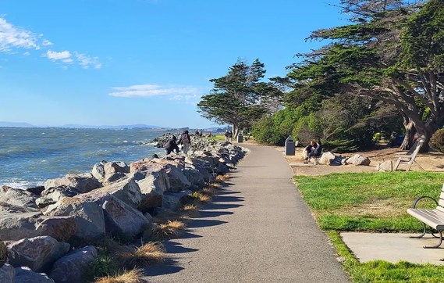  Walkway & riprap |  | Earlier construction experience  Project Manager · Bay Cities Paving & Grading  Concord, California | April 2001–February 2003  Managed civil projects, field coordination, schedules, budgets and owner interfaces. Assignments included Pacheco improvements ($2.6 million)—sewer, drainage, water, joint trench, concrete, landscaping, electrical work and highway widening; O’Brien Middle School ($1.5 million); and Martinez High School site improvements ($1.5 million). Completed Highway 4 slope repair ($0.5 million) in 30 days, including slope modification, anchoring and hydroseeding.  Managed field crews, equipment, subcontractors, procurement, production quantities, budgets and monthly schedules; prepared takeoffs and as-builts.  • I-80 retrofit — $16 million: two bridge widenings, two miles of retaining walls / barriers and three ramps.  • I-80 / Powell — $10 million: bridge widening, ramps, barriers and retaining walls; field production, cost control and subcontractor coordination.  • I-80 improvements — $3.7 million: nine-mile paving program, slide repairs, drainage and ramp widening. Hollis — $1.7 million: underground utilities and major street reconstruction.  Assistant Estimator · Top Grade Construction  Fremont, California | May–August 1997  Prepared Agtek takeoffs, solicited subcontractor and supplier pricing, and supported estimates for projects ranging from $0.5 million to $7 million.  Project Engineer · RGW Construction  I-5, Stockton, California | March–May 1997  Supported bridge widening, two ramps and approximately 1,600 linear feet of retaining walls and barriers. Coordinated schedules, materials, equipment, crews and biweekly cost monitoring.  Handled contract administration, subcontractor payments and liens, quantities, labor dispatch, daily cost monitoring, materials and monthly estimates. Assignments included I-40 Daggett ($3.5 million); I-5 / Highway 14 retrofit ($2.5 million); five bridge retrofits on I-5 and Highways 101, 170 and 10 ($1.8 million); and Palmdale underground works ($0.5 million) involving 48-inch reinforced-concrete pipe.  Supported construction of the $72 million Hemet water-treatment and reservoir project. Prepared schedules, budget / cost breakdowns, takeoffs and supplier / subcontractor pricing; analyzed historical costs and monitored trends and variances.  Project Inspector · Fresno County Public Works  California | April 1988–September 1989  Inspected underground works, guardrail and striping; maintained daily diaries, monitored contractor progress and prepared daily quantities.  Additional early experience: prefabricated truss design / fabrication, part-time concrete estimating and Fresno Unified resource-specialist work.
  Project Engineering Manager · Ghilotti Brothers Construction  San Rafael, California | August 1997–April 2001 | 
  Project Engineer · Granite Construction  Palmdale / Lancaster, California | February 1992–March 1997 | 
  Assistant Project Manager / Assistant Estimator · Kiewit Pacific  Santa Fe Springs / Hemet, California | Assignments in 1990–1991 | 

